**FINAL PROJECT**

**Part 1:**

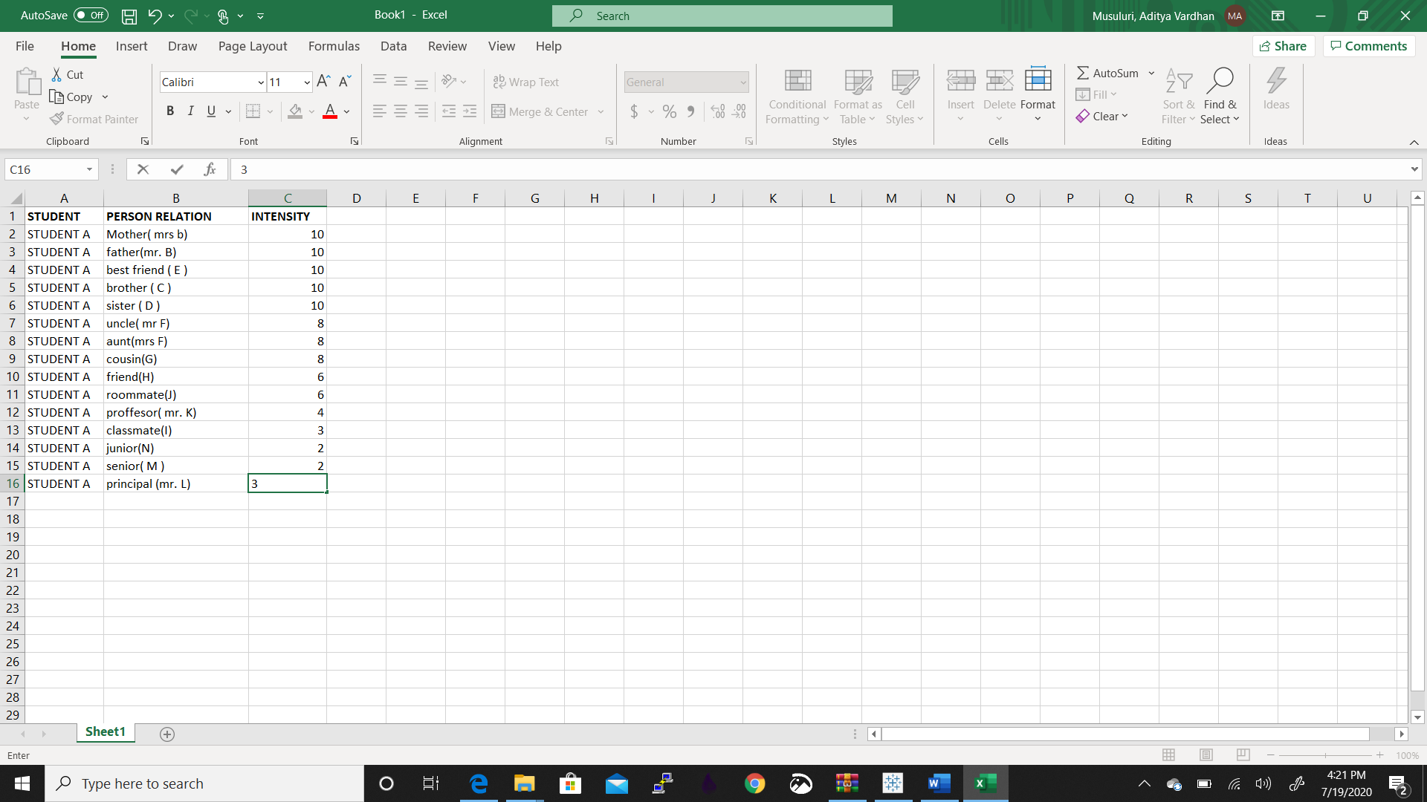

We have to draw a graph with relation between student and other people (up to fifteen)

We used the student_relation.csv dataset for attaining this.

The given data set gives the relation of student A with 15 people. The main attributes in the data set are the relation with the person and the intensity or strength of that particular relation.

The attributes define the following:

STUDENT – name of that student

PERSON RELATION – defining the relationship of the person with the student.

For visualizing this data we have used tableau.

We drew a pie diagram representing the student and his/her relation with the person.

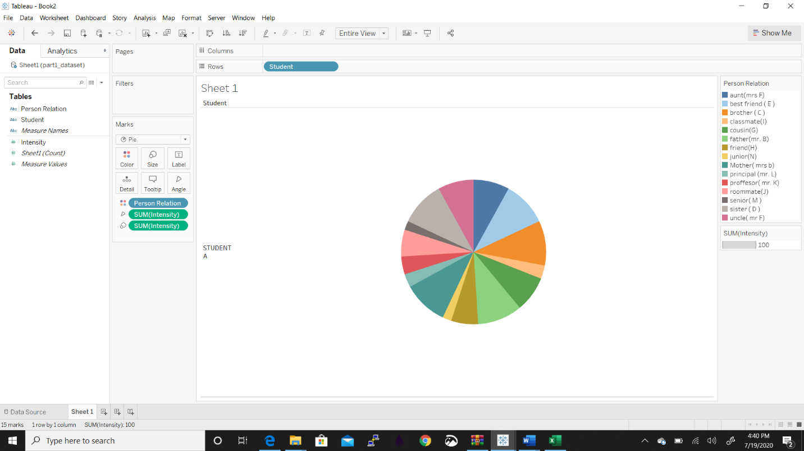



This above pie charts tells the relation with 15 people and the chart has an alphabetical order as we can see on the right side of the image.

We can see that the student has a good bond with his professor than his juniors and seniors.

We can find out the intensity of each relation from the above pie chart.

The student has a good intensity with his uncle than his friend.

**Part 2:**

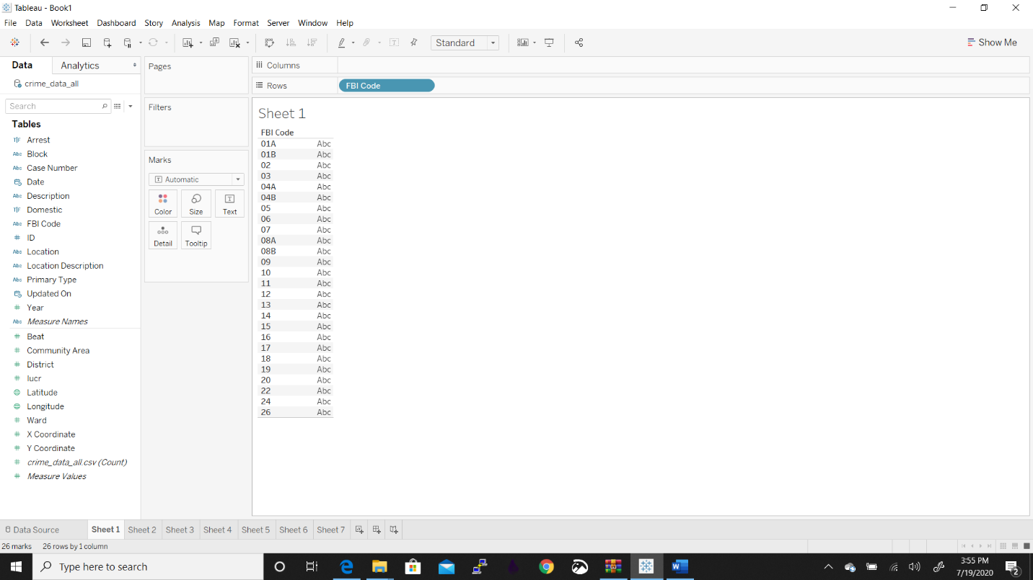



This chart contain FBI code .

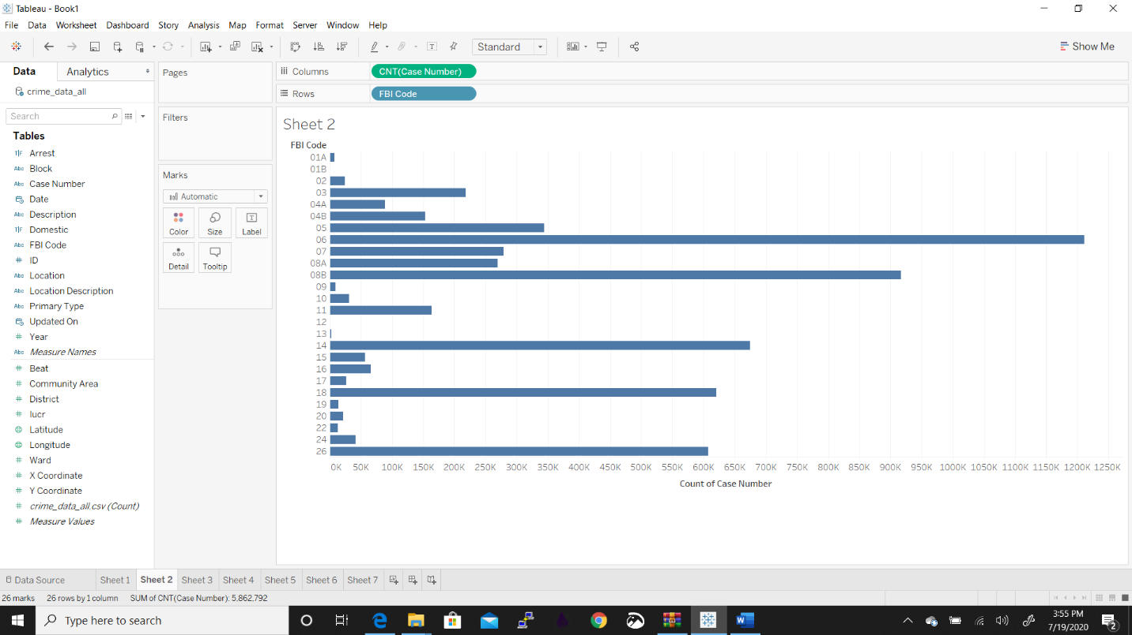



This file contains FBI code and Case Number in rows and columns.

From the above file we can conclude that the count is 26, sum is 5,862,792, average is 225,492, minimum is 22 and maximum is 1,211,080.

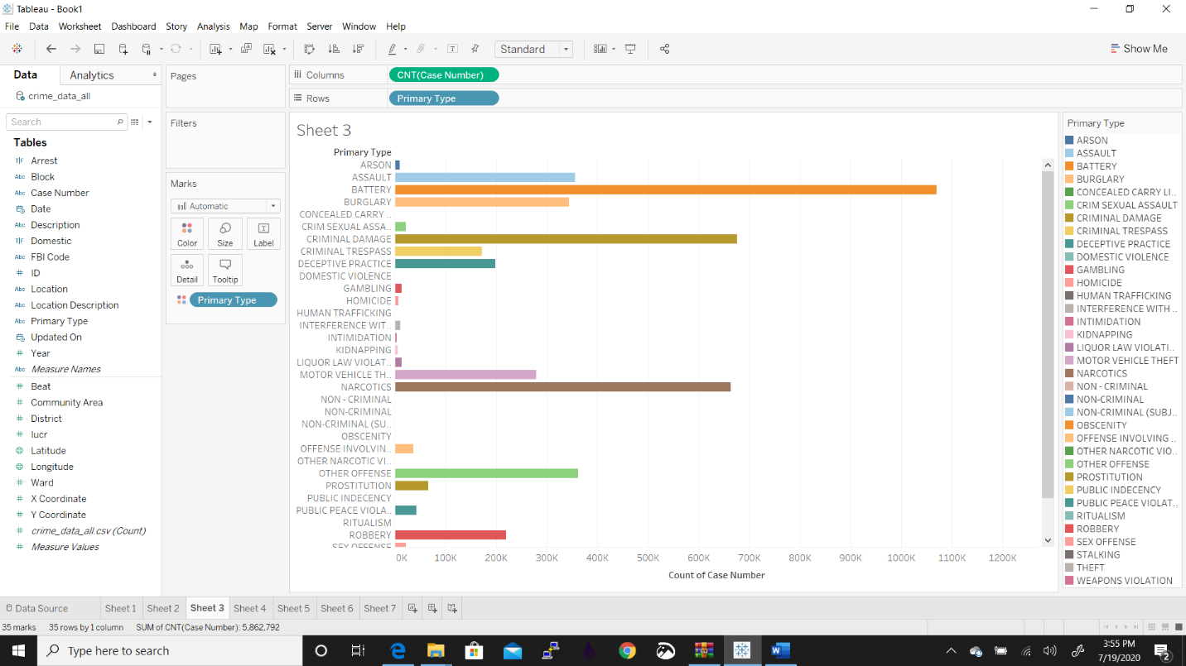



The summary of the above graph is count is 35, sum is 5,862,792, average is 167,508, minimum is 1 and maximum is 1,211,080.

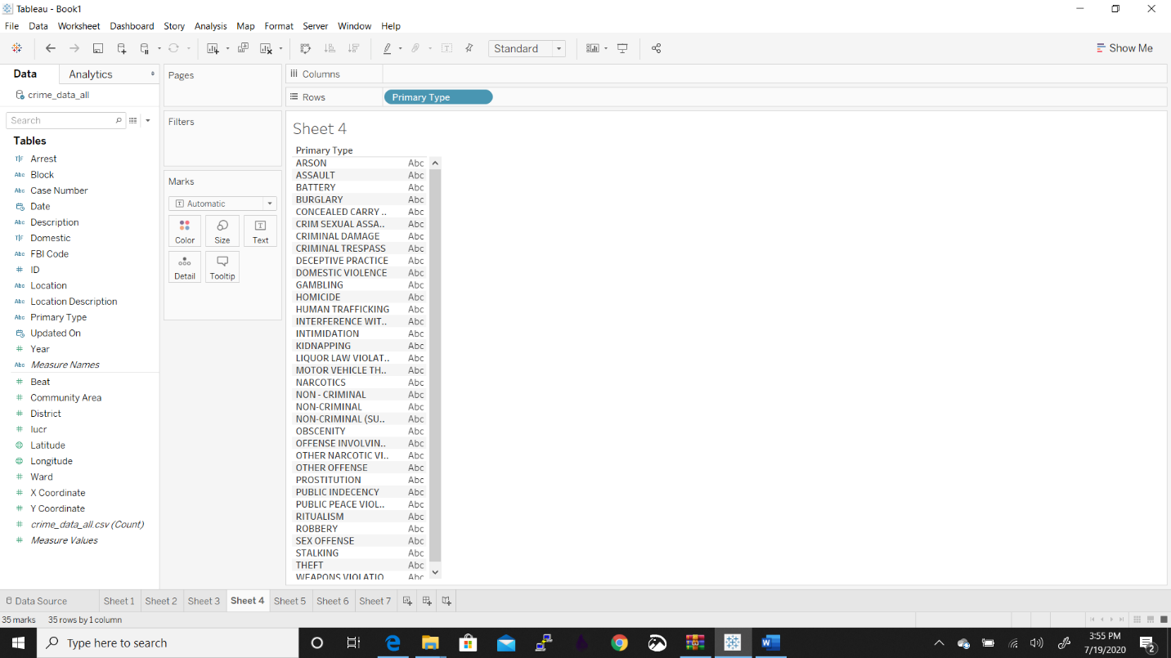



The total count of the chart is 26.

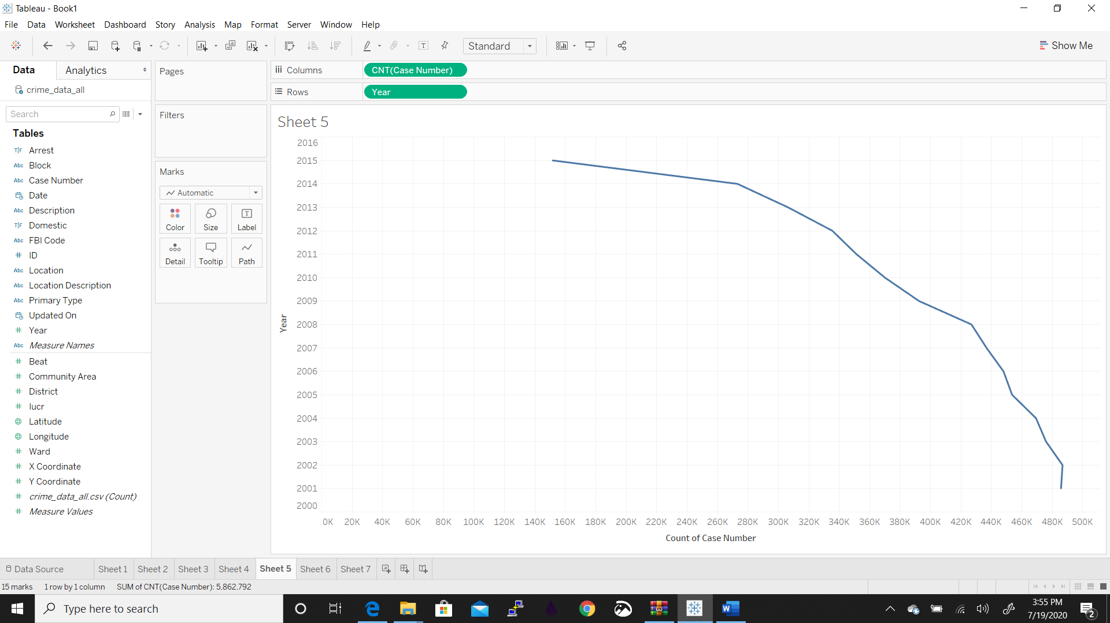



The graph has the case number and year.

The count of the graph is 15.

The sum is 5,862,792

Average is 390,852

Minimum is 151,632 and maximum is 486,703

Median is 426,863.

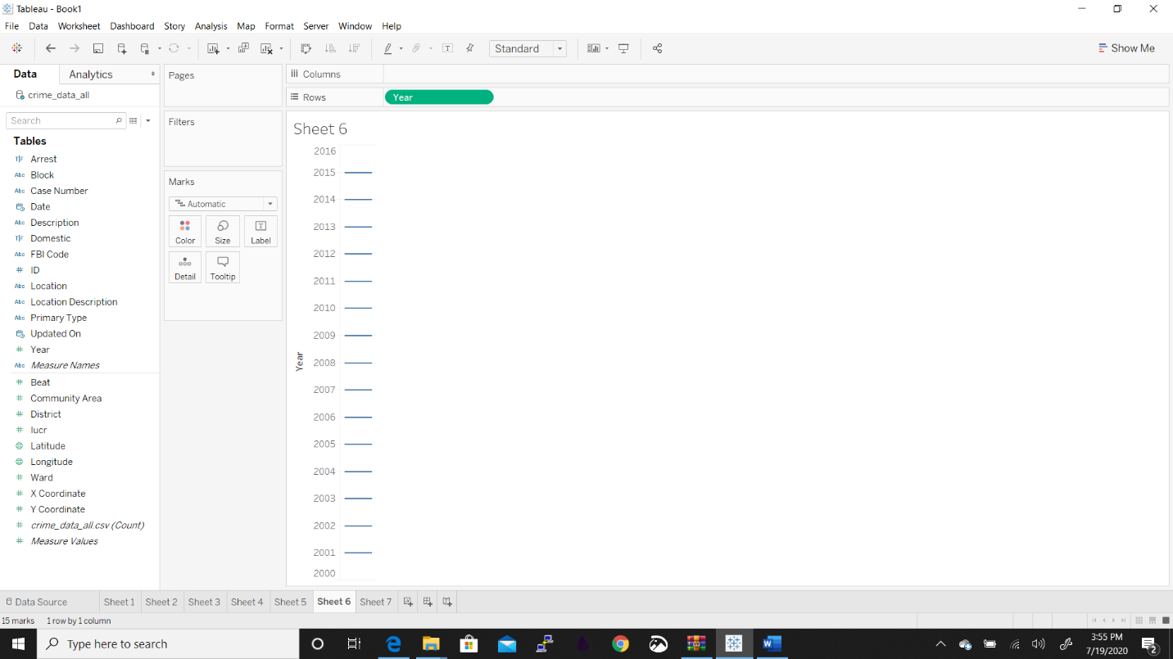



This shows the years that is from 2001 to 2015. So the count is 30.

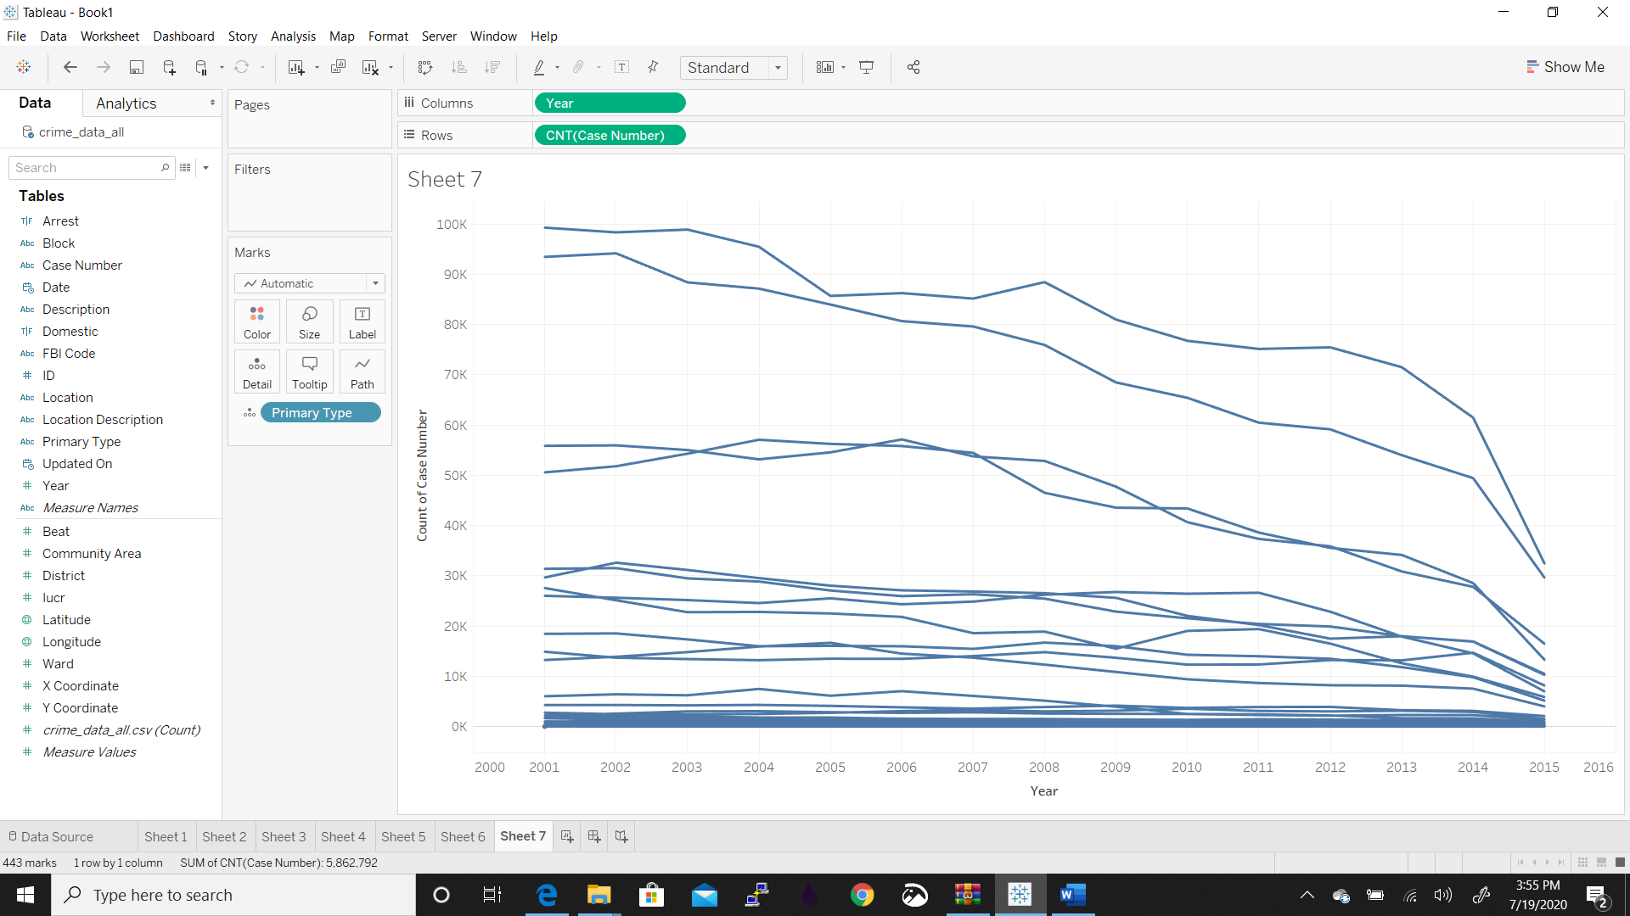



We have taken year and case number in rows and columns.

The count is 443.

Sum is 5,862,792

Average is 13,234.29

Maximum is 99,263 and minimum is 1.

**Part 3:**

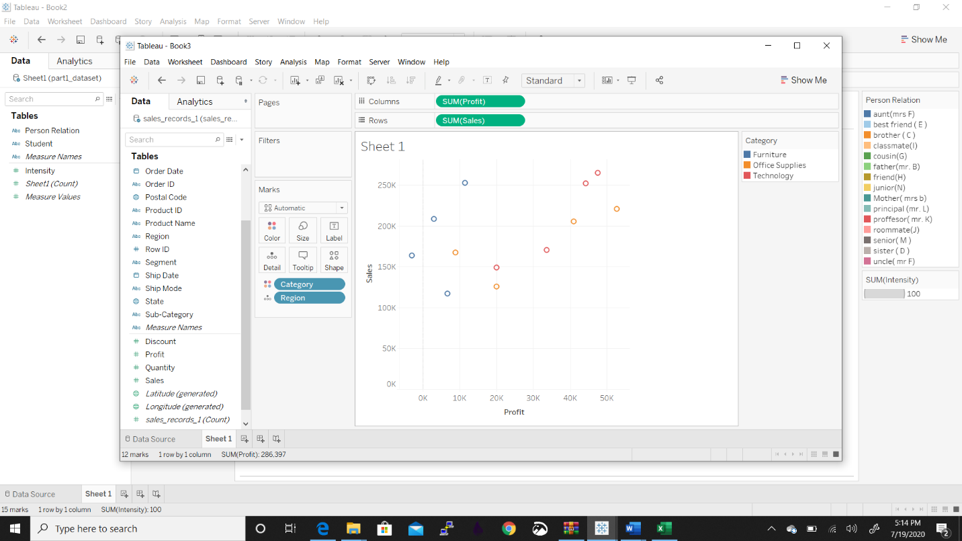



From the above graph we can see that this is a cartesian co-ordinates displaying 2 variables on dataset. AS a collection of points we are displaying this graph.

The sales are maximum in technology category and is very less in furniture category. In Eastern states also the sales are maximum in technology category. Office supplies are least in office supplies category.

In eastern regions the sales is maximum in technology category and is very less in office supplies category.

In central regions the sales are maximum in technology again and the least is in furniture category.

Summary for profit: Count is 12 Sum is 286,397 Average is 23,866 Minimum is 2,871, Maximum is 52,610 and Median is 19,989

Summary for sales: Sum is 2,297,201

Average is 191,433

Minimum is 117,299

Maximum is 264,974

Median is 187,966

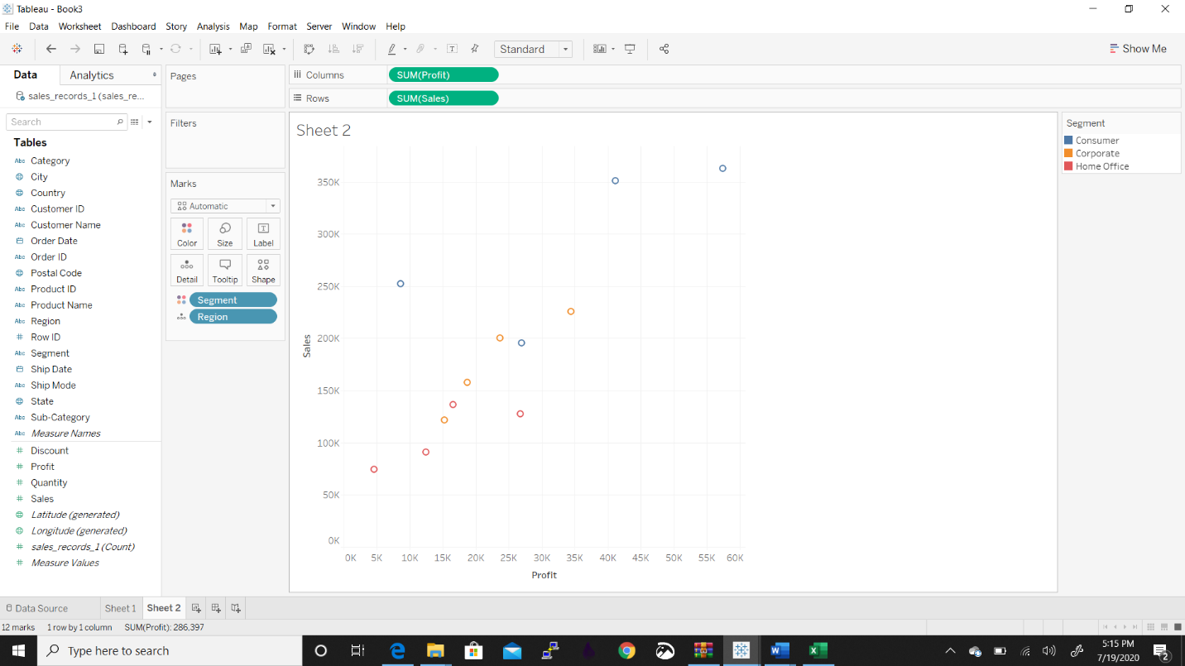



For furniture we have no correlation between marks for sales and the profit in all regions.

We can see the scatter plots and for multivariate data analysis , we need to easily determine relations between dependents and know if the items are linear, non-linear, positive or negative.

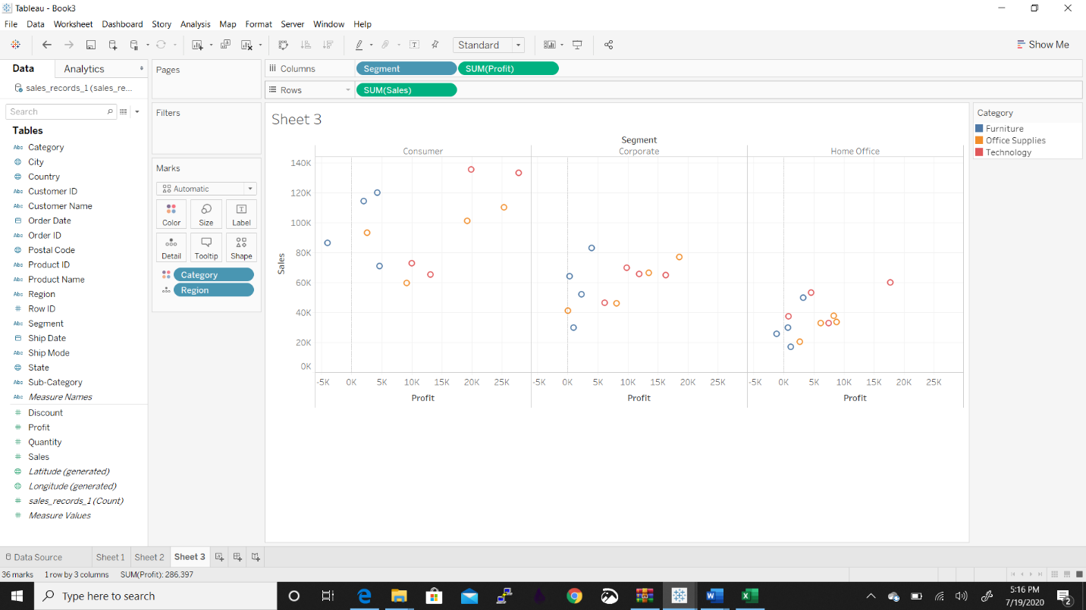



Consumer segment generates max sales and profit from technology category from western and eastern regions. Similarly, the technology category generates max sales in southern category.

Central region has max sales and profit been generated by consumer segment.

Also in corporate segment, the highest sales are recorded in furniture category and in western region least sales are in furniture region.

The corporate region has main category that is Technology in terms of sales and profits too.

In office segment, most lucrative category in terms of sales and profits.

**Part 4:**

**CODE.**



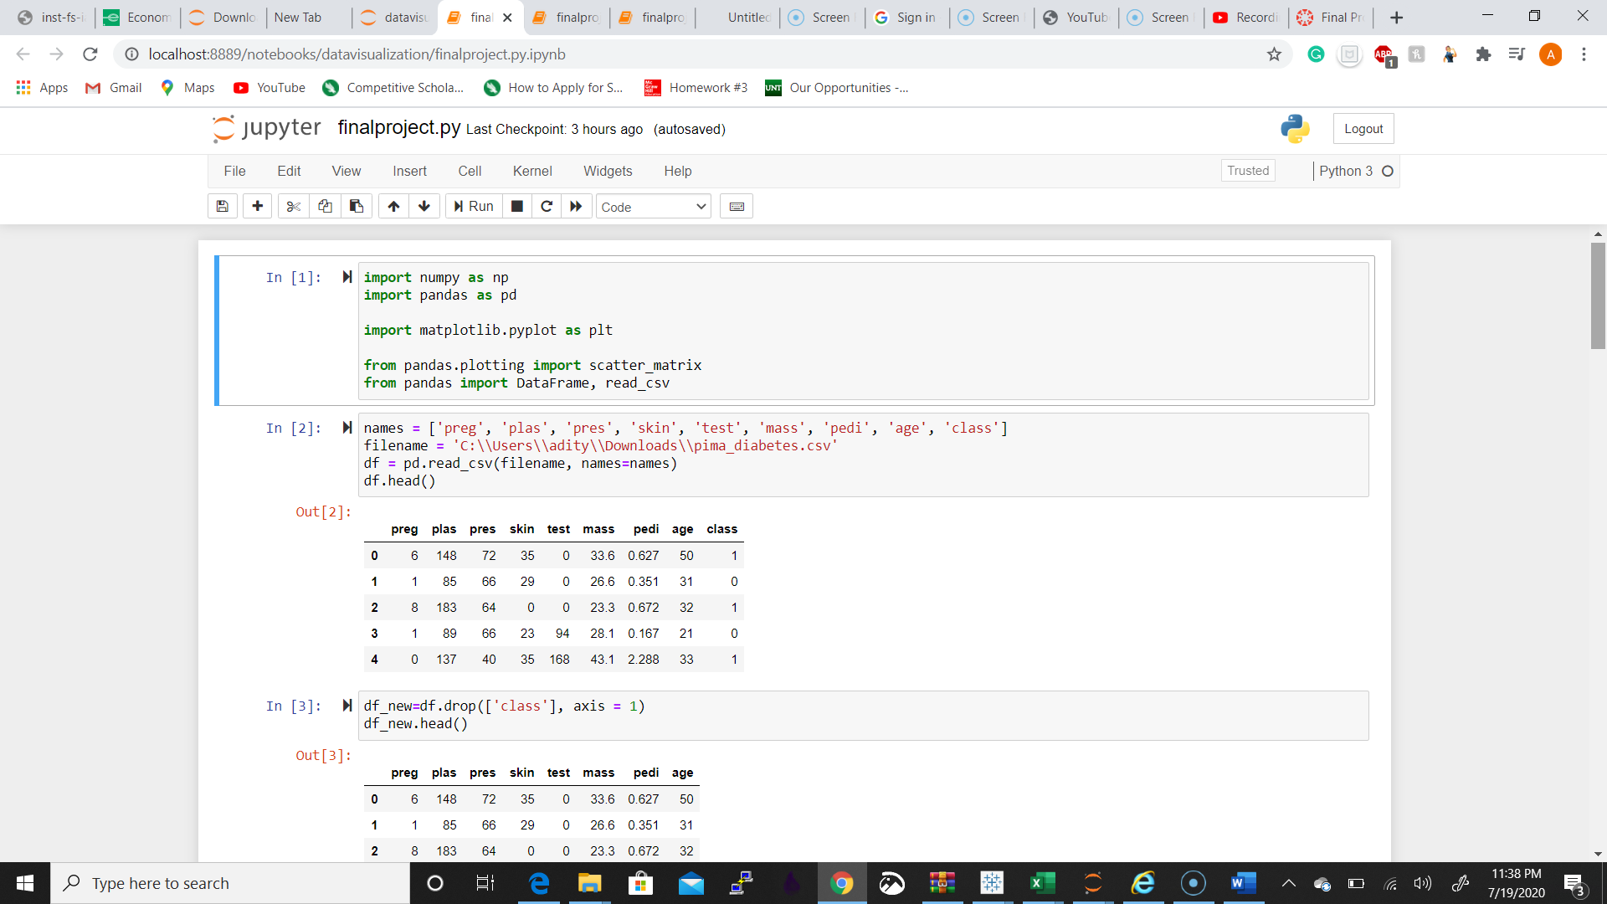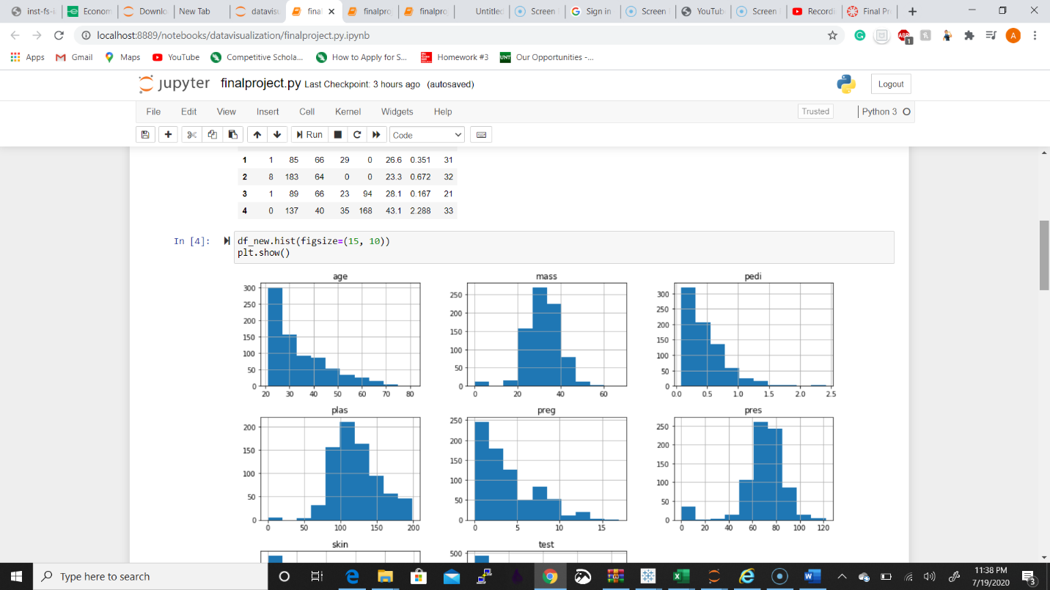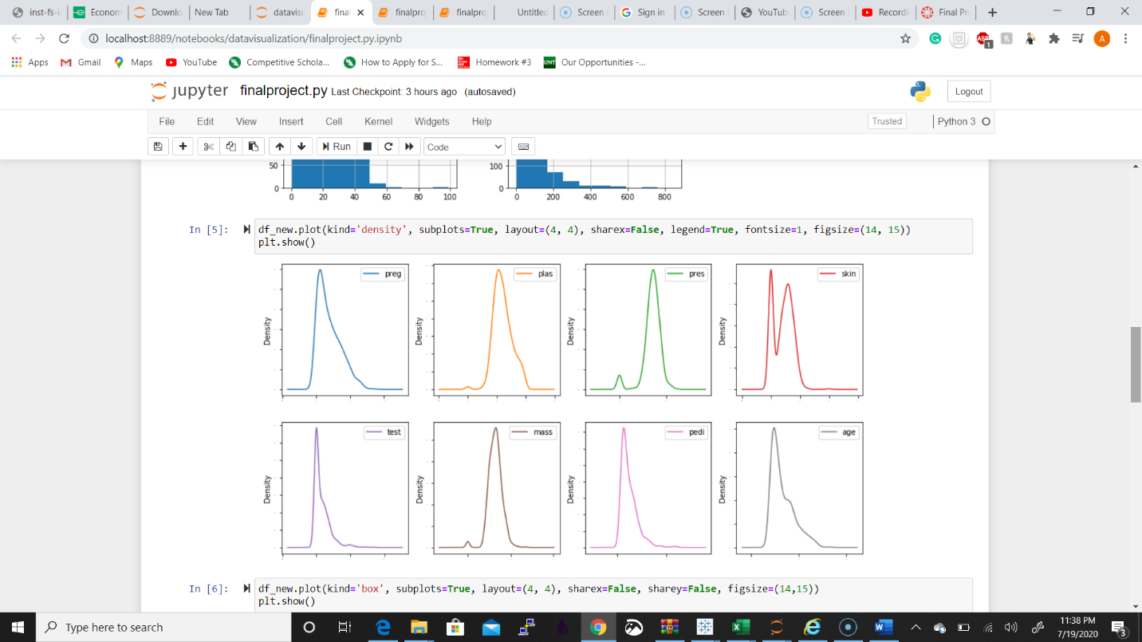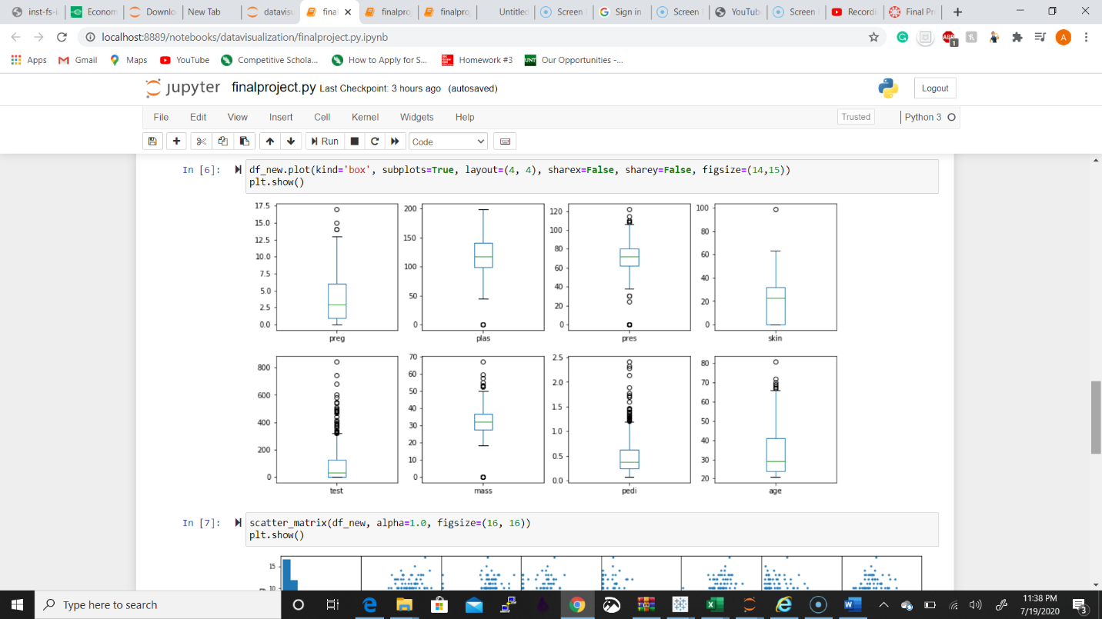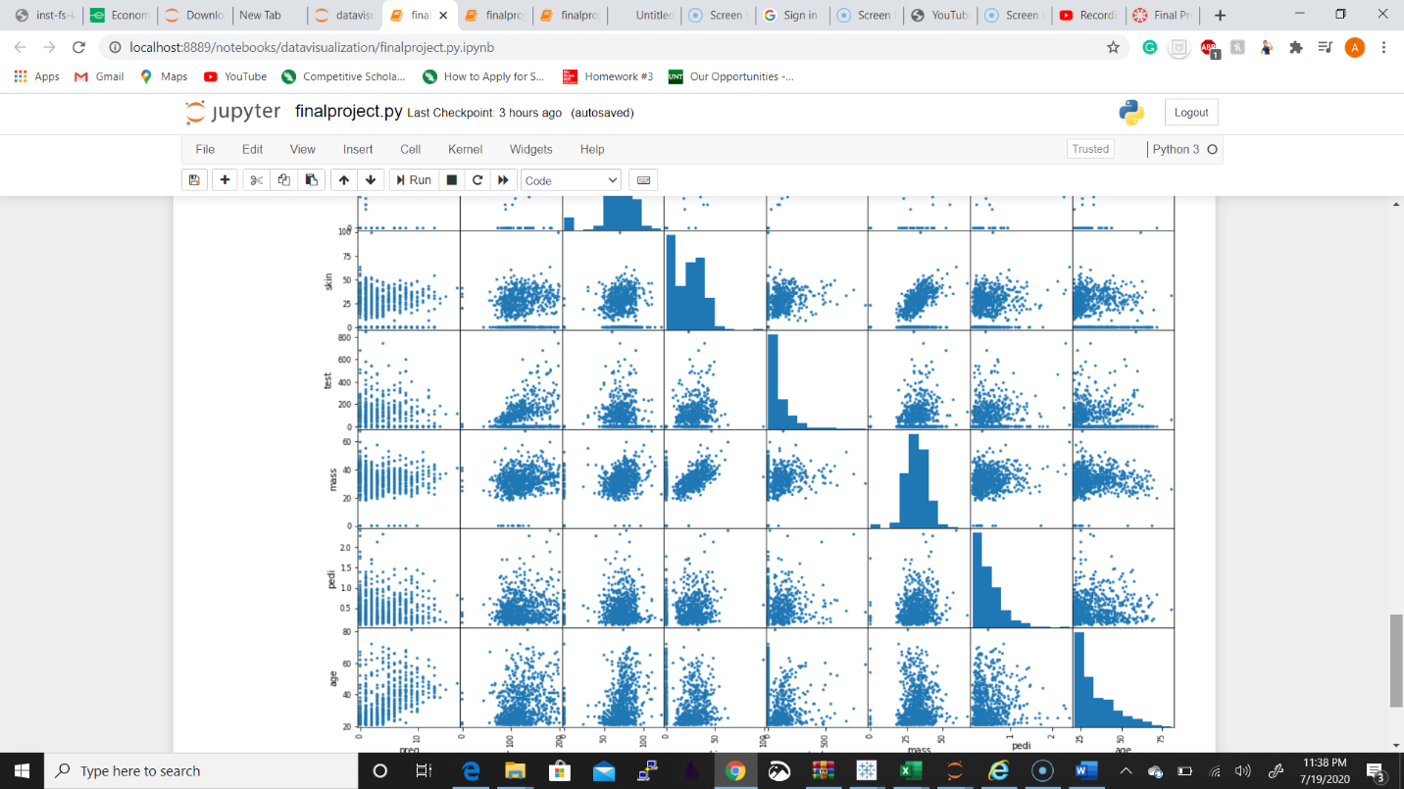

**Video link :** <https://www.youtube.com/watch?v=oXuszk1hsr0&feature=youtu.be&hd=1>